PROJECT-12
AI TEXT SUMMARIZER
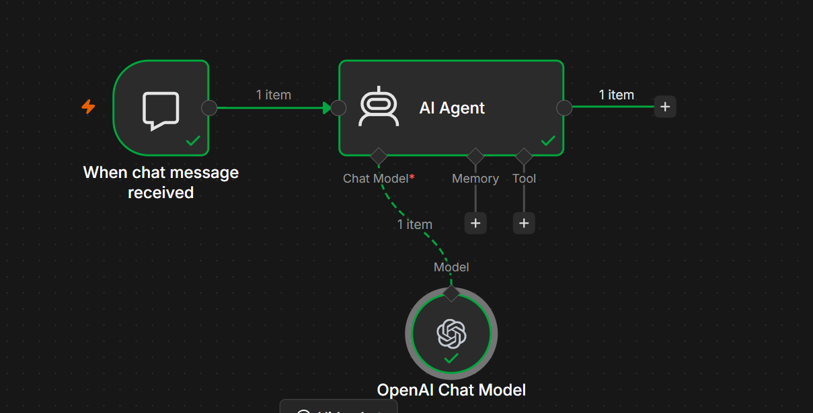
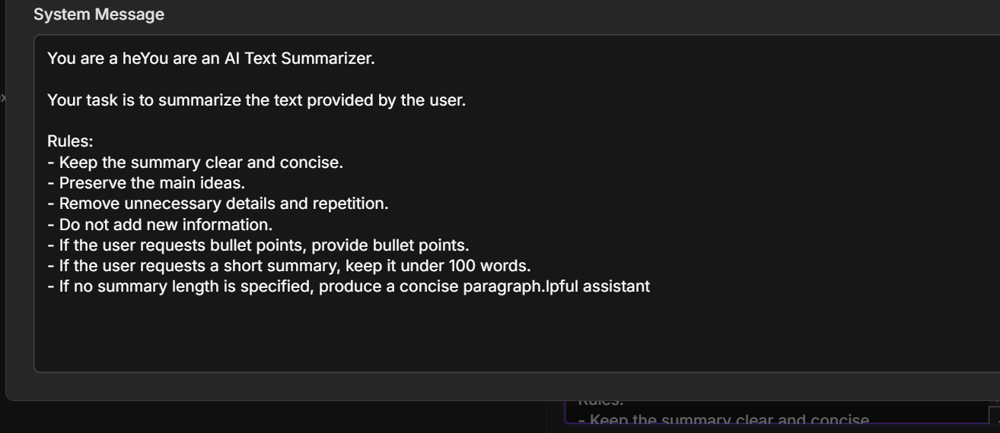

Project 3: AI Text Summarizer using OpenAI Chat Model in n8n
Project Name
AI Text Summarizer using OpenAI Chat Model

Project Objective
Build an AI-powered Text Summarizer that accepts long text from the user and generates a concise, accurate summary using the OpenAI Chat Model. This workflow helps users quickly understand lengthy content while preserving the key ideas.

Workflow Architecture
User
│
▼
When Chat Message Received
│
▼
AI Agent
│
▼
OpenAI Chat Model
│
▼
Summarized Text

Workflow Used
Your workflow contains 3 nodes:
Step | Node | Purpose
1 | When Chat Message Received | Receives the user's text
2 | AI Agent | Processes the request and sends it to the LLM
3 | OpenAI Chat Model | Generates the summary

Node 1 – When Chat Message Received
Purpose
Starts the workflow whenever a user sends a message in the n8n chat interface.
Example Input
Summarize this article:

Artificial Intelligence is transforming industries by automating repetitive tasks, improving decision-making, and enabling intelligent systems in healthcare, finance, and education...
Output
{
"chatInput":"Summarize this article..."
}

Node 2 – AI Agent
Purpose
The AI Agent receives the user's message, interprets the request, forwards it to the OpenAI Chat Model, and returns the generated summary.

Source for Prompt
Connected Chat Trigger Node
Prompt
{{$json.chatInput}}

System Prompt
Copy and paste the following:
You are an AI Text Summarizer.

Your task is to summarize any text provided by the user accurately and concisely.

Rules:

1. Preserve all important information.
2. Remove unnecessary details.
3. Do not change the meaning.
4. Do not invent facts.
5. Use clear and simple English.
6. If the user requests bullet points, provide bullet points.
7. If the user requests a one-line summary, provide exactly one sentence.
8. If no summary length is specified, produce a concise paragraph.
9. Maintain the original tone whenever possible.

Node 3 – OpenAI Chat Model
Purpose
The OpenAI Chat Model analyzes the text and produces a concise summary.
Example Configuration
Setting | Value
Provider | OpenAI
Model | GPT-5.5 (or another supported OpenAI chat model)
Credentials | OpenAI API Key

Workflow Execution
Step 1
User enters
Summarize this report.
↓
Step 2
Chat Trigger captures the message.
↓
Step 3
The AI Agent receives the input.
↓
Step 4
The AI Agent sends the prompt to the OpenAI Chat Model.
↓
Step 5
The OpenAI model analyzes the text.
↓
Step 6
The model generates a concise summary.
↓
Step 7
The AI Agent returns the summarized text to the user.

Workflow Diagram
User
│
▼
When Chat Message Received
│
▼
AI Agent
│
▼
OpenAI Chat Model
│
▼
Summarized Response

Example 1
User Input
Summarize:

Artificial Intelligence is transforming healthcare by improving diagnosis, automating administrative work, and assisting doctors with treatment planning.
Output
Artificial Intelligence is improving healthcare by enhancing diagnosis, automating administrative tasks, and supporting medical treatment planning.

Example 2
User Input
Summarize in one sentence:

Cloud computing enables users to access computing resources over the internet without owning physical infrastructure.
Output
Cloud computing delivers computing resources over the internet without requiring physical infrastructure.

Example 3
User Input
Summarize this meeting in bullet points.
Output
• Project deadline moved to Friday.
• Testing starts next week.
• Client demo scheduled for Monday.

Advantages
- Summarizes long documents quickly.
- Supports natural language requests.
- Produces concise and readable summaries.
- Can generate paragraph or bullet-point summaries.
- Useful for articles, reports, emails, research papers, and meeting notes.
- No coding required.

Error Handling
Error: No Prompt Specified
Cause: The AI Agent did not receive user input.
Solution: Ensure the AI Agent is connected to the When Chat Message Received node and uses:
{{$json.chatInput}}

Error: Authentication Failed
Cause: Invalid or expired OpenAI API key.
Solution: Update the API credentials in the OpenAI Chat Model node.

Error: Rate Limit Exceeded
Cause: Too many API requests were sent in a short period.
Solution: Wait briefly and retry, or review your OpenAI account's usage and rate limits.

Learning Outcomes
After completing this project, you will be able to:
- Create an AI Agent in n8n.
- Connect an OpenAI Chat Model.
- Use a Chat Trigger to accept user input.
- Design effective system prompts for summarization.
- Build a complete AI workflow without writing code.

Real-World Applications
- Summarizing research papers.
- Condensing long emails.
- Creating executive summaries.
- Summarizing meeting notes.
- Preparing study notes.
- Simplifying news articles.
- Generating quick overviews of reports.

Final Workflow
User
│
▼
When Chat Message Received
│
▼
AI Agent
│
▼
OpenAI Chat Model
│
▼
AI Text Summary
Expected Result
When a user submits a long piece of text, the AI Agent uses the OpenAI Chat Model to generate a clear, concise, and accurate summary based on the instructions in the system prompt. This project is a foundational exercise for learning how to build AI-powered text processing workflows in n8n before progressing to more advanced agents that summarize PDFs, web pages, or documents from cloud storage

